PHYSICS NOTES

contents:

LINEAR MOTION AND WAVES 2

UNCERTAINTIES 2

LINEARISING EQUATIONS 3

DISTANCE AND DISPLACEMENT 3

SPEED AND VELOCITY 3

ACCELERATION 4

EQUATIONS OF UNIFORM ACCELERATION 4

GRAPHING MOTION 4

NEWTONS LAWS 5

ELEVATORS 6

MOMENTUM 6

WORK 7

ENERGY 8

POWER 11

*NUCLEAR 12

THE EFFECT OF RADIATION ON HUMANS 15

*NUCLEAR 15

NUCLEAR FISSION 15

NUCLEAR FUSION 16

WAVES 16

WAVE PROPERTIES 16

WAVE BEHAVIOUR (RELFECTION, REFRACTION, DIFFRACTION) 22

WAVE INTERACTIONS – DOPPLER EFFECT, SONIC BOOMS, BEATS 26

WAVE INTERACTIONS – INTERFERENCE PATTERNS 29

WAVE INTERACTIONS – RESONANCE AND HARMONICS 30

HEATING PROCESSES – UNIT 1.1 34

CONDUCTION – UNIT 2.2 35

HEATING AND COOLING 35

SPECIFIC HEAT CAPACITY 41

LATENT HEAT 42

CONDUCTION, CONVECTION, RADIATION 43

APPLICATIONS OF CONDUCTION, CONVECTION, RADIATION 47

ELECTRICITY 51

RESISTANCE 56

unit two

# LINEAR MOTION AND WAVES

EQUATIONS:

KEY:

a=acceleration

v=final velocity

u=initial velocity

s=displacement/distance

$$a=\frac{v-u}{t}$$

$$s=ut+\frac{1}{2}{at}^{2}$$

$$v=u+at$$

$$v^{2}=u^{2}+2as$$

# UNCERTAINTIES

A = 12±1

NOTE:

% and relative uncertainty = %

Absolute = number

B = 6±0.1

ADDING or SUBTRACTING

C = A+B

= 12 + 6 *add absolute uncertainties

= 18 ± 1.1

MULTIPLYING or DIVING or POWERS

C = AxB2 = AxBxB *add % uncertainties

A = 12±1, % uncert. = $\frac{1}{12}×100$ ∴8.3%

B = 6.0±0.1, % uncert. = $\frac{0.1}{6}×100$ ∴1.7%

C = AxB2 = AxBxB

= 12x6x6 uncert = A% + B% + B%

=432 = 8.3 + 1.7 + 1.7 = 11.7%

0.117x432 = 51 ∴432±51

# LINEARISING EQUATIONS

# DISTANCE AND DISPLACEMENT

Distance travelled, d = length of path covered during an objects entire journey (scalar, measured in m)

Displacement, s = straight line distance travelled from start to finish (vector, measured in m with a direction)

# SPEED AND VELOCITY

AVERAGE SPEED AND VELOCITY

vav = <-------- average/mean speed (scalar)

vav = <-------- average/mean velocity (vector)

*note: velocity needs a direction

CHANGE IN VELOCITY AND SPEED

Change in speed = $∆\text{v=v}-\text{u}$ (final minus initial speed) – scalar

Change in velocity = $∆\text{v=v}-\text{u}$ (final minus initial velocity) – vector

# ACCELERATION

ACCELERATION

$$a=\frac{change in velocity}{time taken}=\frac{v-u}{t}$$

a = acceleration (m/s2)

v = final velocity (m/s)

u = initial velocity (m/s)

t = time (seconds)

VERTICAL ACCELERATION

* At the Earth’s surface, the acceleration due to gravity is -9.8m/s2 down towards the Earth’s centre

# EQUATIONS OF UNIFORM ACCELERATION

EQUATIONS:

Only one that doesn’t have time

Don’t try to solve unless u=0

$$v=u+at$$

$$a=\frac{v-u}{t}$$

$$s=ut+\frac{1}{2}{at}^{2}$$

$$v^{2}=u^{2}+2as$$

KEY:

v = final velocity (m/s)

u = initial velocity (m/s)

a = acceleration (m/s2)

t = time (seconds)

s = distance/displacement (m)

# GRAPHING MOTION

Position-time graphs

To find:

Displacement: final position – initial position

Velocity: find the gradient

Instantaneous velocity: (used when the graph is curved) find the gradient of the tangent to the line at the point of interest

Velocity-time graphs

To find:

Displacement: area under the graph

Acceleration: find the gradient of a velocity time graph

Acceleration-time graphs

To find:

Change in velocity (∆v): area under the graph

*note: in order to establish the actual velocity, the initial velocity must already be known

# NEWTONS LAWS

What do forces do? Push or pull

Units: Newtons (N)

Two types of forces: contact + non-contact

FIRST LAW – INERTIA

* Property of matter by which it continues in its existing state of rest or uniform motion
* Relates to the objects mass
* More mass = more inertia

an object will maintain a constant velocity unless an unbalanced, external force acts on it

balanced and unbalanced forces

SECOND LAW – F=ma

F = net force on an object (Newtons – N)

m = mass (kg)

a = acceleration (m/s2)

# ELEVATORS

Weight: the downwards force exerted upon an object by the Earth’s gravity

Apparent weight: the normal force (⊥ to the surface)

Normal force: the force that a spring weighing scale measured and it is the force that is responsible for our sensation of ‘weight’

Elevator ‘excursion’

# MOMENTUM

P = momentum (kgms-1) or (N.s)

M = mass (kg)

V = velocity (m/s)

IMPULSE (CHANGE IN MOMENTUM)

$$I=F×t=∆p$$

F = force (in N.S – newton seconds)

$∆p$ = change in momentum $\left(mv-mu\right)$

Therefore: if $∆p$ = constant = $Ft$ (if one increases the other decreases)

Why things ‘cushion’ the impact

* $∆p$ = constant = Ft
* $↑t=↓F$ (∴ less energy)
* u and v are going to be the same just adding time = less injury

CONSERVATION OF MOMENTUM

# WORK

F: Force

s or d: distance

Units for work:

Newtons x metres

= Joules (J)

EXAMPLES:

A force of 50N is exerted for 3m

* W = 50 x 3 = 150 J

A box of mass 10kg falls 2m

* Force of gravity = mg = 10 x 9.8 = 98N
* Work = 98 x 2 = 196 J

A box is pushed at a constant speed of 2m/s for 12m against a frictional force of 5N

* 12 m x 5 N = 60 J

SUMMARY

* Work is calculated using the formula:
$W=Fdcosθ$

* When $θ=90°$, the force is perpendicular to the displacement and no work is done
* When the force is parallel to the displacement, $θ=90°$, so W=Fd
* Work can also be found by calculating the area under a Force vs distance graph
* The units for work is Joules (J), which is an abbreviation for Newton metre (N m)

# ENERGY

* Energy is the ability to do work
* There are different kinds of energy
  + Gravitational energy
  + Thermal energy
  + Electrical energy
  + Spring energy
  + Light energy
  + Kinetic energy
* Energy of one kind can be changed into another kind

GRAVITATIONAL ENERGY

* A 10 kg rock is 5.0 m above the ground. How much gravitational energy does it have?
* Energy is the ability to do work, and *W = Fs*
* The force of gravity is *mg = 10 × 9.8 = 98 N*
* The distance the rock can fall is *s = 5.0 m*
* Earth’s gravity is able to do 98 N × 5.0 m = 490 J of work.
* **It has 490 J of gravitational energy.**

THERMAL ENERGY

example: A large wooden box is dragged along the floor at a constant speed against a frictional force of 100 N for 50 m. As a result its lower surface becomes hot. What thermal energy was developed?

* W = F s = 100 × 50 = 5 000 J.
* **Thermal energy of 5000 J heated the lower surface of the box.**

ELECTRICAL ENERGY

example: A set of six AAA batteries is able to get a toy aeroplane propeller to exert a force of 12 N for 1800 m before they go flat. How much electrical energy can one AAA battery provide?

* Energy is the ability to do work, and *W = Fs*
* The six batteries are able to do 12 N × 1800 m = 21 600 J of work.
* **One battery provides 21600 ÷ 6 = 3600 J of electrical energy.**

SPRING ENERGY

example: A windup toy car stores energy in a spring. It can travel for 12 m against a frictional force of 0.60 N. How much spring energy does it have when fully wound?

* Energy is the ability to do work, and *W = Fs*
* The spring is able to do 0.60 N × 12 m = 7.2 J of work.
* **The windup toy has 7.2 J of spring energy.**

LIGHT ENERGY

example: A light sail is ultra-thin plastic that reflects sunlight. The sunlight pushes it with a weak force of 0.15 millinewtons for 100 000 km. How much light energy is this?

* Energy is the ability to do work, and W = Fs

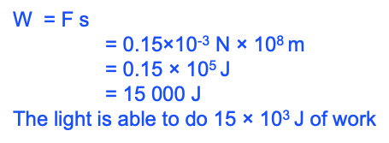

* F = 0.15 × 10-3 N
* d = 100 000 × 103 m
* **The light energy is 15 kJ.**

KINETIC ENERGY

* Kinetic energy is energy of ***movement***.
* The word comes from the same origin as Cinema (***moving*** pictures).
* When something is moving it keeps moving for a distance *s* until the friction force *F* stops it.
* It is able to do work *Fs* so it has energy.

example: A 1200 kg car is travelling at 20 ms-1 but it slows to a stop over 300 m when the engine is switched off, due to friction.

* s = 300, u = 20, v = 0, a =?, t =
* v2 = u2 + 2 a s
* = 400 + 2 × a × 300
* A = -0.6666... m s-2
* Therefore F = m a = 1200× - 0.6666... = -800 N

example: A 1200 kg car is travelling at 20 ms-1 but it slows to a stop over 300 m when the engine is switched off, due to friction.

* The force ***on*** the car is -800 N, so the force ***by*** the car is +800 N
* W = F s= 800 × 300 = 240 000 J
* The car is able to do 240 × 103 J of work
* **The moving car has 240 kJ of kinetic energy**

GRAVITATIONAL ENERGY

The force is mg and the distance moved is the height above the ground.

W = F s = (mg) × h

Gravitational energy = mgh

SPRING ENERGY

* The more you stretch a spring, the bigger the force it exerts.
* The work is the area under the F vs distance graph.
* Triangle area   
  = ½ k x × x

When you stretch a spring by a distance x, the energy stored is ½ kx2

* k is called the spring constant.
* k is the slope of the Force vs distance graph.
* k is different for different springs.

ALTERNATIVE WAYS OF CALCULATING ENERGY

Apart from calculating the ability to do work there are other quick short cuts for calculating energy.

The formulae for electrical energy and light energy will be studied next semester.

ELASTIC AND INELASTIC

* if kinetic energy before and after are the same = elastic
* If kinetic energy before and after are different = inelastic
  + Energy is still conserved though
* <http://mrwaynesclass.com/teacher/Impulse/SimFriction/home.html>

# POWER

* The rate of change of energy

$$P=\frac{W}{t} or \frac{change in energy}{time}$$

W = work

t = time

The unit for power is the unit of work ÷ the unit of time

$$\frac{J}{s}={Js}^{-1}$$

There is also an alternative formula for power: $$P=Fv$$

Power = Force × distance ÷ time   
 = Force × (distance ÷ time)   
 = Force × velocity

example: A does 1000 J of work in 20 s. B does 2000 J of work in 50 s. Who is working faster?

* A does 1000/20 = 50 joule of work each second.
* B does 2000/50 = 40 joule of work each second.
* **A is working faster. We say that A is exerting more Power.**

example: A car engine does 500 J of work in each second. How much power is it producing?

* 500 W

example: A truck engine exerts a driving force of 400 N to enable it to keep moving at a constant speed, against friction. How much Power does it produce while travelling 1 km in 40 s?

* Work = Force × distance = 400 × 1000
* = 400 000 J
* Power = Work ÷ time = 400 000 ÷ 40
* = 10 000 W

example: A truck engine exerts a driving force of 400 N to enable it to keep moving at a constant speed, against friction. How much Power does it produce while travelling 1 km in 40 s?

* Work = Force × distance = 400 × 1000
* = 400 000 J
* Power = Work ÷ time = 400 000 ÷ 40
* = 10 000 W

example: A jet engine in an aeroplane exerts a thrust force of 12 000 N to enable it to keep moving at a constant speed, against friction. How much power does it produce while travelling 400 m in 2 seconds ?

* Power = Force × distance ÷ time
* = 12 000 × 400 ÷ 2
* = 2 400 000 W

example: A truck engine provides a driving force of 400 N to enable it to keep moving at a constant speed, against friction. How much Power does it produce while travelling 72 km/h

* 72 km h-1 = 20 m s-1
* Power = Force × velocity = 400 × 20
* = 8000 W

# *NUCLEAR

RADIATION – WHAT IS IT?

* The emission of energy as electromagnetic waves or as moving subatomic particles

Non-ionizing radiation is low energy electromagnetic radiation

Ionizing radiation is high-energy radiation that can affect the electrons surrounding an atom so that a charged ion is formed

THE 2 KINDS OF BACKGROUND RADIATION:

* Terrestrial radiation
* Cosmic radiation

ATOMIC THEORY

-----DIAGRAM WITH ATOMIC THEORY

WHAT HOLDS A NUCLIDE TOGETHER?

There are 4 fundamental forces:

* Strong
* Weak
* Electrostatic
* Gravitational

The strong nuclear force acts to hold nucleons together against the force of electrostatic repulsion

STABILITY OF NUCLIDES

* Protons and neutrons are tightly packed into the nucleus
* The positive charges of the protons should repel each other, but they don’t
* Nuclear force keeps protons and neutrons stuck together in the nucleus
* It is 100 times stronger than the repulsive electric force between the protons. The nuclear force is a short range force (only acts over a short distance)
* The larger the nucleus, the less tightly the protons and neutrons are held together (because distance between them has increased)
* When the nuclear force is sufficiently strong, the nuclide is stable. Otherwise the nuclide is unstable and will emit radiation

Unstable atoms are radioactive and an individual radioactive isotope is known as a radioisotope

HALF-LIFE

* The decay rate of a radioisotope is measured in terms in its half-life (t1/2)
* The half-life of a radioisotope is the time that it takes for half of the nuclei of the sample to spontaneously decay

IMAGE

* A half diagram is an exponential function (it never reaches 0)

M&M HALF-LIFE EXPERIMENT

|  |  |  |  |  |
| --- | --- | --- | --- | --- |
|  | Number of undecayed M&Ms | | |  |
| HALF-LIVES | TRIAL 1 | TRIAL 2 | TRIAL 3 | AVERAGE |
| 0 | 173 | 174 | 171 | 173 |
| 1 | 95 | 92 | 95 | 94 |
| 2 | 43 | 44 | 61 | 49 |
| 3 | 25 | 27 | 39 | 30 |
| 4 | 15 | 18 | 20 | 18 |
| 5 | 8 | 10 | 10 | 9 |
| 6 | 3 | 4 | 5 | 4 |
| 7 | 2 | 2 | 3 | 2 |
| 8 | 1 | 1 | 2 | 1 |
| 9 | 0 | 1 | 1 | 1 |
| 10 | 0 | 1 | 0 | 0 |

GRAPH OF THE AVERAGES:

HALF-LIFE EQUATION

In general, for a sample of N0 particles, the number, N, remaining after n half-lives is given by the equation:

N0 = starting (number of nuclei you have)

N = remaining

EXAMPLE QUESTION 1 (USING NUMBER OF NUCLEI)

*A sample of the radioactive thorium-234 contains 8.0 x 1012 nuclei. The half-life of 234Th is 24 days. How many thorium-234 atoms will remain in the sample after:*

1. *24 days?*
$$N= N_{0}{(\frac{1}{2})}^{n}$$

$$N=8.0×{10}^{12}$$

$$n= \frac{24}{24}=1$$

$$∴ = 8.0×{10}^{12}{(\frac{1}{2})}^{1} =4×{10}^{12}$$

2. *48 days?*

ANSWER

1. *96 days?*

ANSWER

EXAMPLE QUESTION 2 (USING ACTIVITY)

*In 2 hours, the activity of a sample of a radioactive element falls from 240 Bq to 30 Bq. What is the half-life of this element?*

240 🡪 120 🡪 60 🡪 30

Count the arrows = 3 half-lives

3 half-lives in 2 hours (120mins)

∴ t1/2 = = 40mins

RADIO ACTIVITY

* The number of radioactive decay occurring in a sample each second is the activity of the sample

$$Activity \left(A\right)=∆N/t$$

Where ∆N is the change in the number of nuclei present (or decays or counts) and t is the time

* Activity is measured in becquerels (Bq)
* 1 Bq = 1 disintegration per second

*Note: over 1 half-life the activity of a sample will be reduced by half*

## THE EFFECT OF RADIATION ON HUMANS

ABSORBED DOSE

The energy cells absorb from radiation is called absorbed dose

* Radiation damage depends on 2 factors
  + The energy the cell absorbs
  + The time over which the cell absorbs the energy

Absorbed dose: $\frac{energy absorbed}{mass of body part}$

* This is measured in joules per kg of tissue
* The unit of absorbed dose = Gray (Gy)
* 1 Gy = 1 joule per kg (J.Kg-1)

DOSE EQUIVALENT

$$dose eqivalent=absorbed dose×quality factor$$

* this is measured in Sieverts (Sv)
* 1 Sv = 1 joule per kg (J.kg-1)

# *NUCLEAR

## NUCLEAR FISSION

* Nuclear fission occurs when an atom splits into 2 or more pieces. This is often triggered by the absorption of a neutron

DIAGRAM-----

Elements capable of undergoing nuclear fission are known as fissile materials. Only a handful of isotopes have this property, including U-235 and Pu-239

Energy Released:

* In any fission reaction, the combined mass of the incident neutron and the target nucleus is always greater than the combined mass of the fission fragments and the released neutrons.

This decrease in mass* is equivalent to the energy released during each fission and can be determined by using:

$$E=∆mc^{2}$$

E = energy released (joules)

∆m = mass decrease (kg)

C = speed of light ($3×{10}^{8} {ms}^{-1}$)

(*the decrease in mass is referred to as the total binding energy of the nucleus. It represents the amount of energy that is needed to hold the nuclide together)

The electron-volt (eV)

* One electron-volt (eV) is an energy unit
* It is equivalent to the energy that an electron gains when it is exposed to a one volt potential difference
* Thus, 1 electron-volt is equivalent to $1.602×{10}^{-19}$ J

## NUCLEAR FUSION

* Occurs in the sun and the stars and is how heavier elements are formed from light nuclei such as hydrogen and helium
* Involves joining 2 small nuclei to form a large one
* When this happens, energy is released and there is a mass defect (binding energy of reactants > binding energy of products)

Binding energy per nucleon: divide by the number of nucleons

* Trying to make it more stable (you want a greater binding energy per nucleon)

NUCLEOSYNTHESIS

* The process of forming heavier nucleotides by fusion is called nucleosynthesis
  + (usually used in fission)

# WAVES

## WAVE PROPERTIES

WAVES: WHAT ARE THEY?

A wave is a travelling disturbance

It involves energy being transferred from one place to another without the net transfer of matter

2 major categories:

* Those which rely on an elastic medium to carry them (mechanical waves)
* Those which require no medium

THE 2 TYPES OF WAVES

Transverse

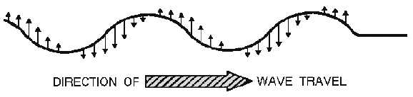

Longitudinal

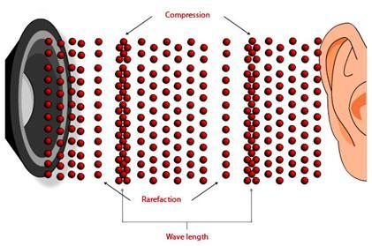

TRANSVERSE WAVES

A transverse wave is one in which the displacement of the particles occurs perpendicular to the direction of travel of the wave

* Radio waves, light waves, and microwaves are transverse waves
* Transverse waves also travel on the strings of instruments such as guitars and banjos



LONGITUDINAL WAVES

A longitudinal wave is one in which the displacement of the particles is parallel to the line of travel of the wave

* A sound wave is a longitudinal wave



PERIODIC WAVES

If the source of the disturbance produces it repeatedly, at equal time intervals, the resulting wave is called periodic

* Many periodic waves in nature are sinusoidal waves, represented by sine and cosine graphs
* Like anything else periodic, these waves are characterized by: an amplitude, a wavelength, a period, and a frequency





Amplitude A is the maximum displacement from the particle’s undisturbed position

Wavelength λ is the horizontal length of one wave cycle (or the distance a wave travels during 1 period)

LONGITUDINAL WAVES REPRESENTED PICTORIALLY AS A TRANSVERSE WAVE

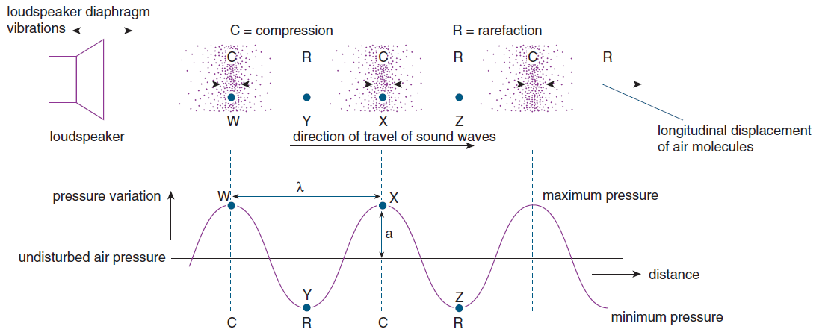

THE RELATIONSHIP BETWEEN T AND f

Period T: time required for one complete cycle

Frequency f: number of cycles per second of time

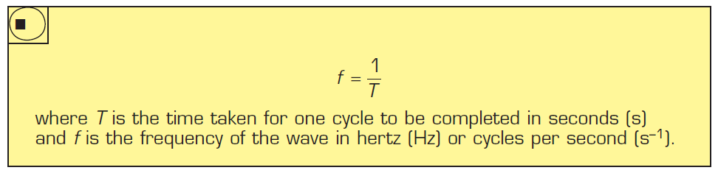

THE WAVE EQUATION

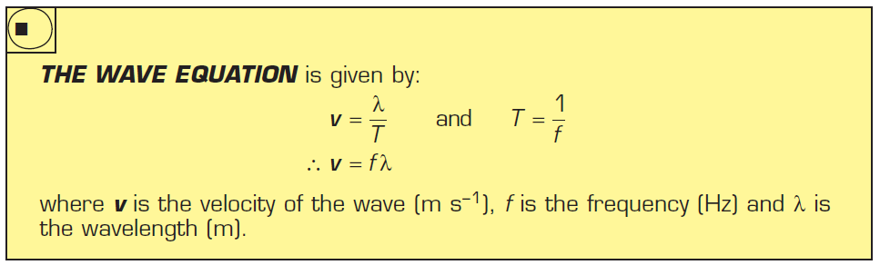

SOUND

Sound is a longitudinal wave in which the disturbance is a change in the pressure in the air (or other medium)

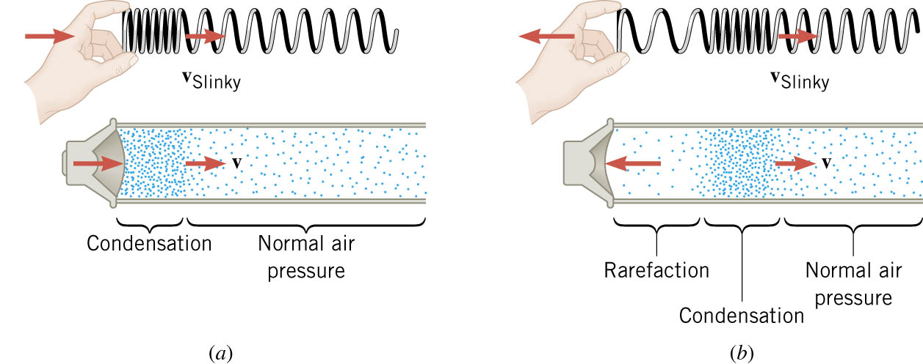

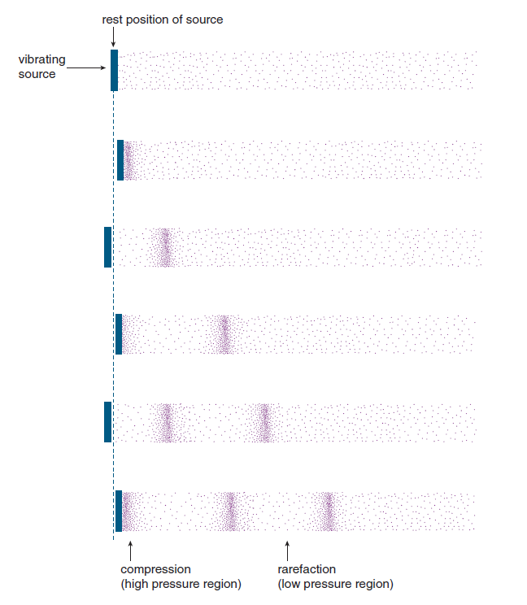

Like any wave, sound is characterized by a velocity and a wavelength

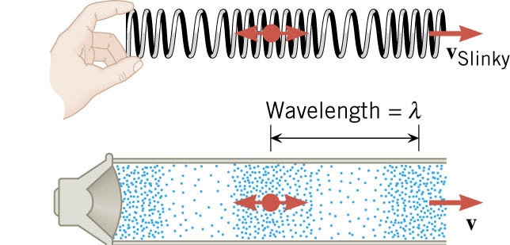

As with any wave, the disturbance travels, and energy travels, but the material (air) “sloshes back and forth” mostly in one place

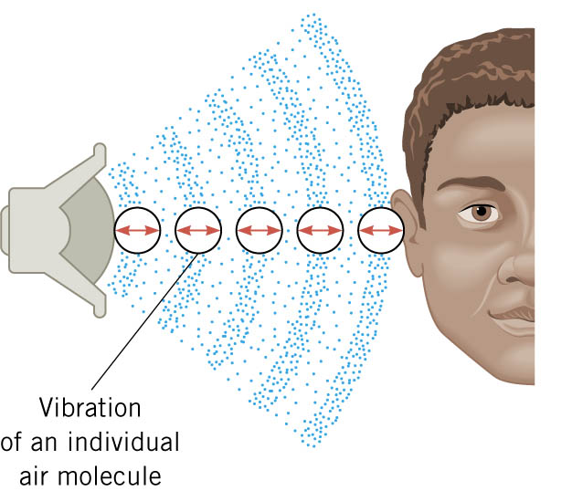

HOW AMPLITUDE AND FREQUENCY CHANGE WITH PITCH AND LOUDNESS

a source that vibrates rapidly produces sound of a higher pitch (or frequency)

Summary:

Higher pitch = higher frequency

Louder sound = larger amplitude

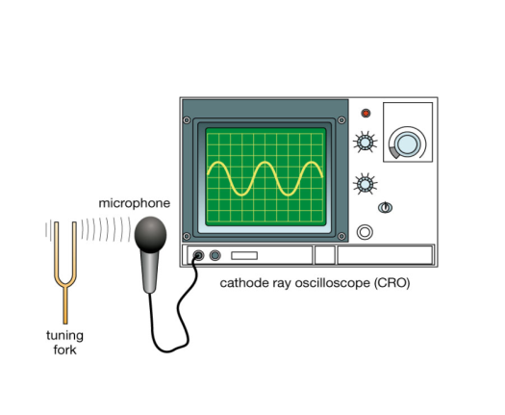

## WAVE BEHAVIOUR (RELFECTION, REFRACTION, DIFFRACTION)

REPRESENTING WAVES

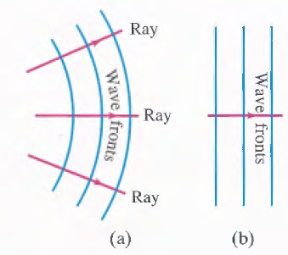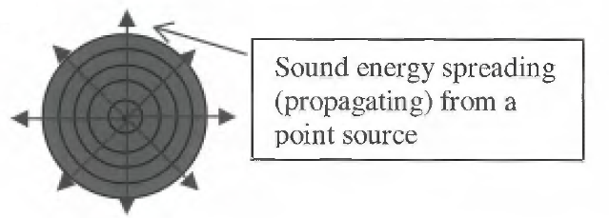

Wave fronts – points along the wave which form the wave crest

Rays signify the direction of wav motion, are always perpendicular to wave fronts

(a) Circular or spherical waves near the source.

(b) Far from the source, the wave fronts are nearly straight or flat. Called plane waves.

THE INTENSITY OF WAVES

Waves from a point source will spread out uniformly into the surrounding space, likewise, the energy at the source becomes spread out over larger and larger areas as the light travels away from the source

$$I∝\frac{1}{r^{2}}$$

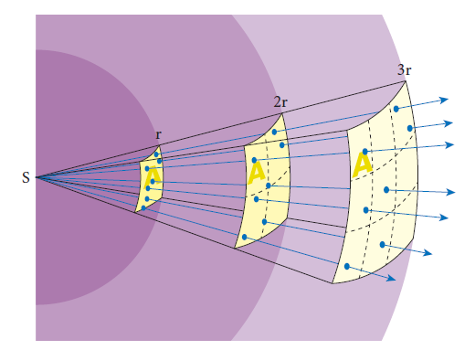

MATHEMATICAL PROOF OF INVERSE SQUARE RELATIONSHIP FOR WAVE INTENSITY:

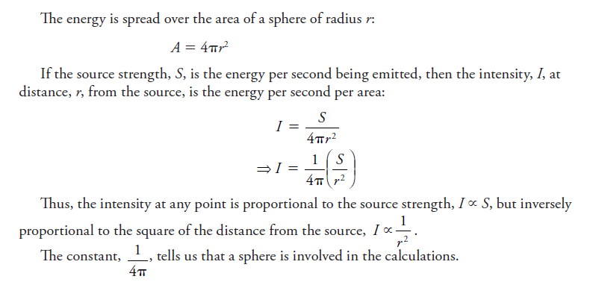

LAW OF REFLECTION

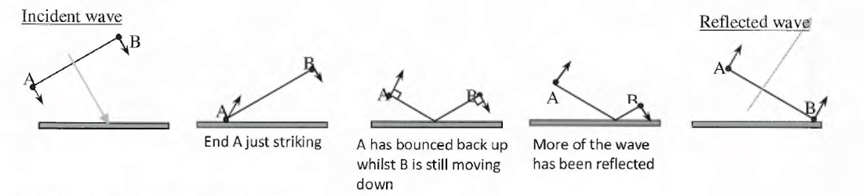

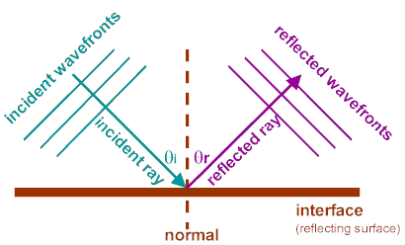

Law of reflection: Angle of incidence = Angle of reflection

NOTE: When sound is reflected in the same medium, there is no change in its frequency, speed or wavelength

WAVES MEETING BARRIERS

* At the boundary of the medium, the energy that was being carried by the wave may undergo different processes – some may be absorbed by or transmitted into a new medium, and some energy may be reflected
* The extent to which these processes occur depends on the properties of the boundary

WAVE REFRACTION

* Refraction = bending of waves
* Occurs when the wave changes from one medium to another

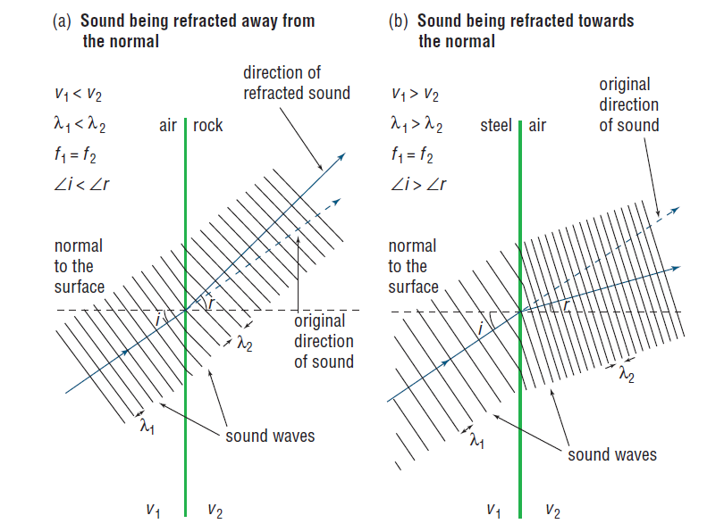

WAVE REFRACTION AND SNELL’S LAW

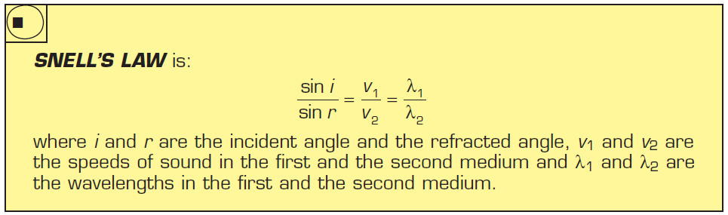

* Not in formula sheet – must memorise!*

NOTE: Air temp can be considered as two different media as sound travels faster in warmer air

(because collisions of molecules in warm air is greater as they have more energy)

Does v, f, λ of refracted waves change?

(v and λ change, f remains constant (it’s a fundamental property of the wave))

TOTAL INTERNAL REFLECTION

* Can occur when $v_{1}<v_{2}$
* Minimum angle at which total internal reflection occurs = critical angle (at this point the angle of reflection = 90°

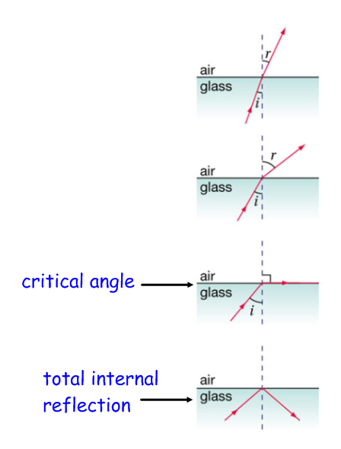 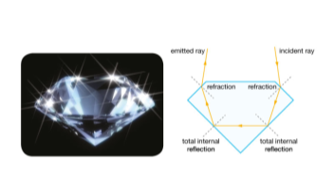

DIFFRACTION OF SOUND

Diffraction: the bending of waves as they pass the edge/s of an obstacle or pass through an aperture (hole/slit)

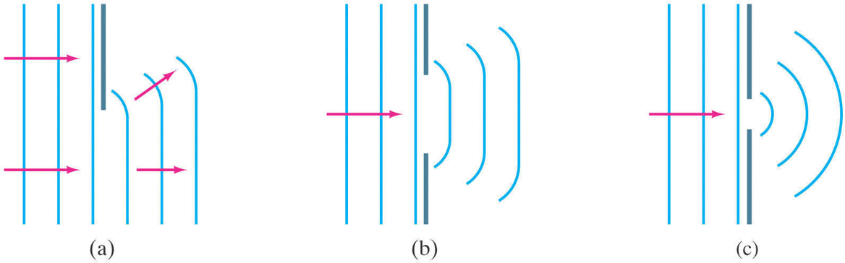

(a) Waves passing through an aperture or past an obstacle that > λ will **not** be significantly diffracted – leaves ‘sound shadows’.

(b) Apertures or obstacles that are **comparable (same order of magnitude) to λ or smaller** will cause significant diffraction.

Significant diffraction occurs when $\frac{λ}{width} ≈1$ or more

SUMMARY

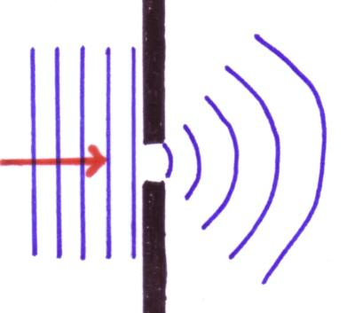

λ > d reflects

λ = d sphere shaped diffraction  
λ < d limited diffraction

## WAVE INTERACTIONS – DOPPLER EFFECT, SONIC BOOMS, BEATS

DOPPLER EFFECT

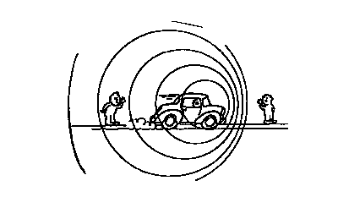

* Frequency (f) of a wave can also vary due to the movement of the source of the wave or the receiver of the wave
* If the source or receiver other wave are moving together, the wave will decrease its λ an increase it f
* If the source or receiver are moving apart, the λ will be longer and the f will be lower

A THOUGHT TO CONSIDER…

Many people think that the Doppler effect depends on the distance between the source and the observer. While the intensity of a sound varied as the distance changes, the apparent frequency depends only on the relative speed of source and observer. As you listen to an approaching source, you will detect increasing intensity but constant frequency. As the source passes, you will hear the frequency suddenly drop to a new constant value and the intensity begin to decrease.

DOPPLER EFFECT AND RED SHIFT

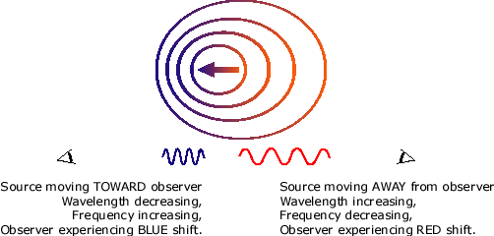

SONIC BOOMS

An intense pressure front builds up on the cone and is the cause of the shock wave known as a sonic boom

The shock wave advances at the speed of sound *v*, and since it is built up from all of the combined wave fronts, the sound heard by an observer will be quite intense.

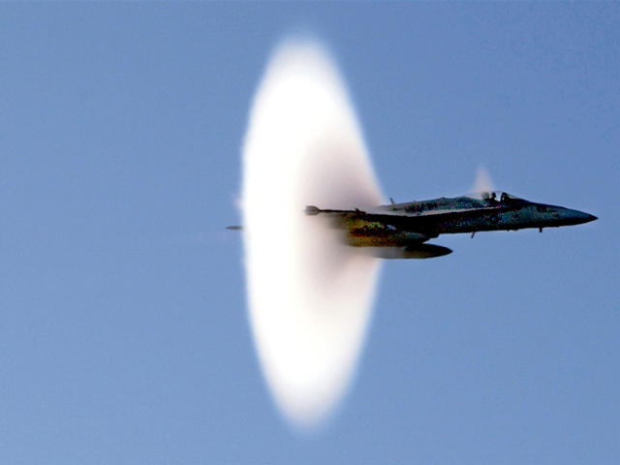

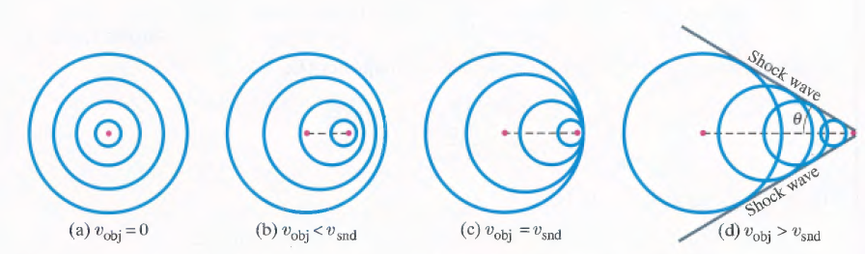

BEATS – INTERFERENCE IN TIME

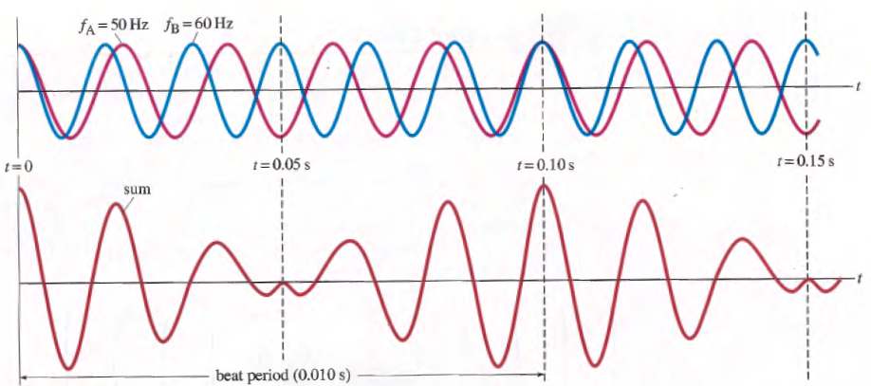

**\* Beat frequency = difference in 2 wave frequencies

$$f_{B}=f_{2}-f_{1}$$

 \***

CONSTRUCTIVE AND DESTRUCTIVE INTERFERENCE

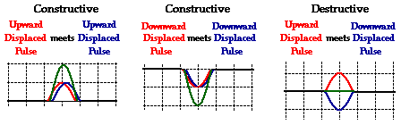

WHAT DO WE NEED FOR BEATS TO OCCUR?

* Waves need to be close in frequency but not exactly the same
* Waves must be travelling in the same medium at the same time
* Will occur even if the amplitudes are not equal, as long as the difference in amplitudes is not great

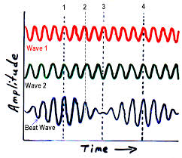

REAL WORLD APPLICATION: HOW BEATS ARE USED

A piano tuner frequently utilizes the phenomenon of beats to tune a piano string. She will pluck the string and tap a tuning fork at the same time. If the two sound sources - the piano string and the tuning fork - produce detectable beats then their frequencies are not identical. She will then adjust the tension of the piano string and repeat the process until the beats can no longer be heard. As the piano string becomes more in tune with the tuning fork, the beat frequency will be reduced and approach 0 Hz. When beats are no longer heard, the piano string is tuned to the tuning fork; that is, they play the same frequency.

## WAVE INTERACTIONS – INTERFERENCE PATTERNS

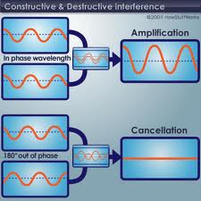

Constructive Interference (produces an **antinode**)

Destructive Interference (produces a **node**)

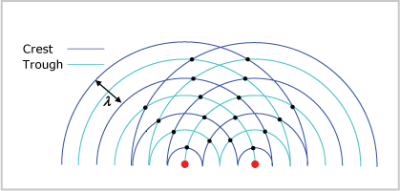

Regions of total **destructive** interference (nodes) are shown as **black** dots.

Regions of total **constructive** interference (antinodes) are shown as **blue** dots.

Notice the nodes are aligned, symmetrical and based on where troughs coincide with crests – the waves here are out of step

INTERFERENCE BY REFLECTION

 <https://phet.colorado.edu/en/simulation/sound>

INTERFERENCE AND SOUND WAVES

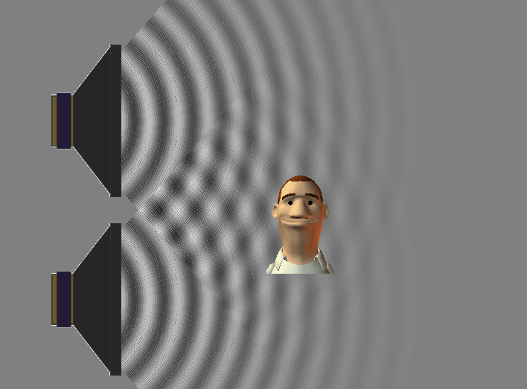

## WAVE INTERACTIONS – RESONANCE AND HARMONICS

RESONANCE

* https://[www.youtube.com/watch?v=urYWaHfel6g](https://www.youtube.com/watch?v=urYWaHfel6g)
* The frequency or frequencies at which an object tends to vibrate with when hit, struck, plucked, strummed or somehow disturbed is known as the natural frequency of the object.
* Resonance occurs when the frequency of a forcing vibration = natural frequency of an object
* At resonance, relatively little effort is required to obtain a large amplitude

PHYSICS IN ACTION: RESONANT COLLAPSE

* It has been reported that a railway bridge collapsed because a nick in one of the wheels of a crossing train set up a resonant vibration in the bridge
* Marching soldiers break step when crossing a bridge to avoid the possibility that their rhythmic march might match a resonant frequency of the bridge
* The collapse of the Tacoma Narrows Bridge in 1940 occurred as a result of gusting winds whose approximate frequency matched that of a natural frequency of the bridge, thus driving the span into large-amplitude oscillatory motion

STANDING WAVES

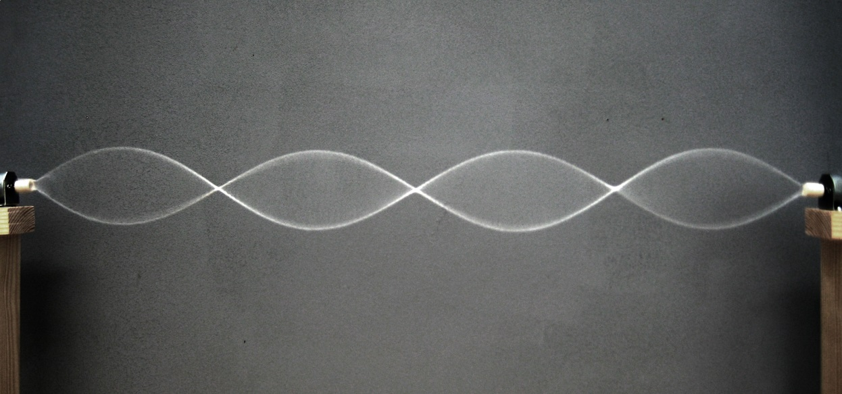

Nodes are the bits in the middle and the antinodes are the tops of the waves

* While the appear stationary the string continually oscillates. It is the relative position of the nodes and antinodes that remain unchanged
* The result of the interference of 2 waves travelling in opposite directions.
* Are produced at the natural frequencies

VIBRATIONS IN STRETCHED STRINGS

* Stretched strings will freely vibrate at a particular natural frequencies. These frequencies are dependent upon the length of the string, its mass and its tension

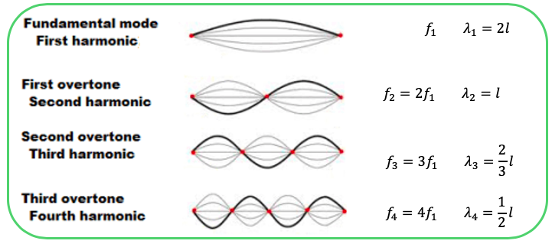

By applying the wave equation to the diagram on the previous slide, we can deduce the following equations:

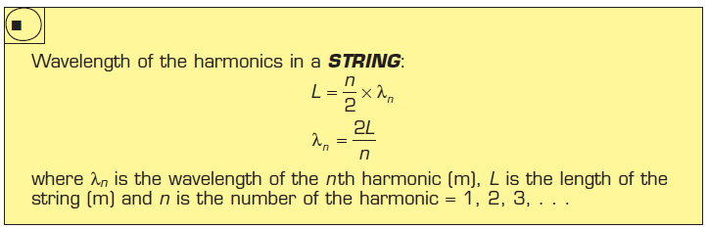

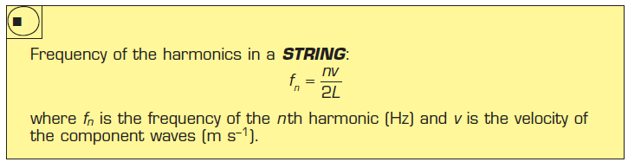

WIND INSTUMENTS

* Stationary waves are also possible in air columns.
* Blowing over the hole of a flute produces vibrations that correspond to a range of frequencies.
* The air within the tube vibrates with a variety of frequencies but only frequencies that correspond to standing waves will persist. This is determined by the length of the pipe.
* Waves can be described either in terms of the displacement of air (like in your study guides) or in terms of the pressure in the air (like in your Heinemann text).

OPEN PIPES (E.G. FLUTE)

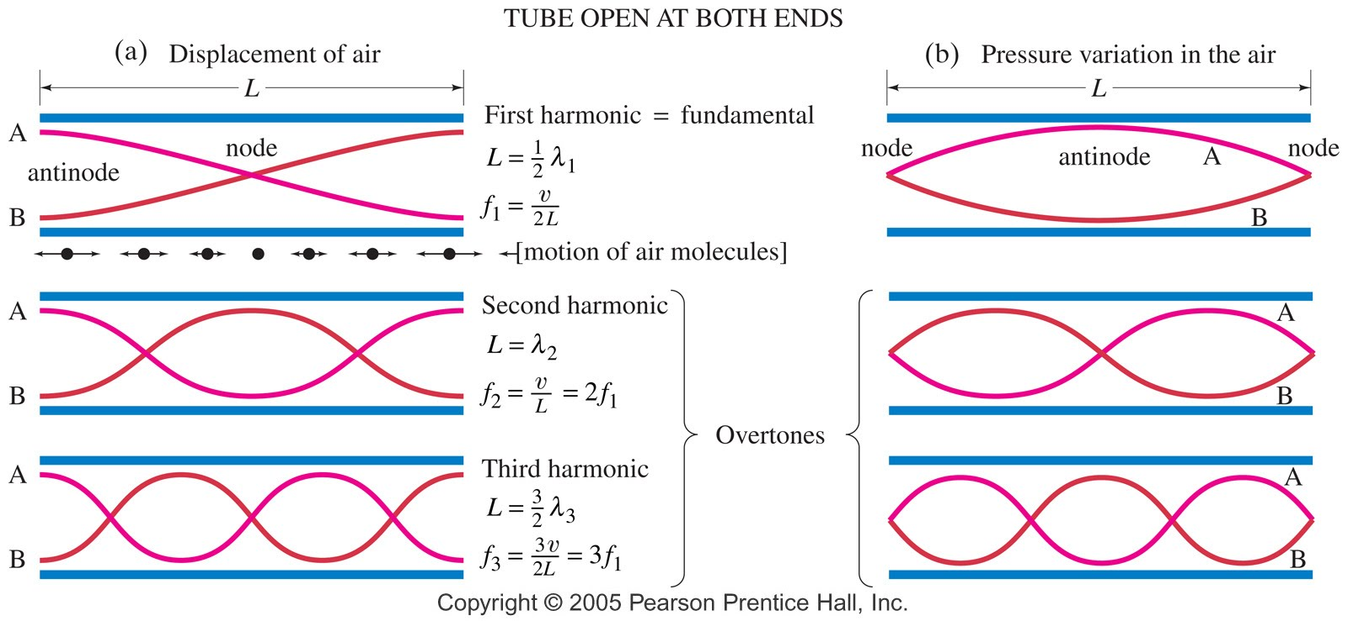

Each graph shows the wave format at 2 times, A and B, a half period apart.

The actual motion of the molecules for one case, the fundamental, is shown just below the tube at top left.

OPEN PIPES: EQUATIONS

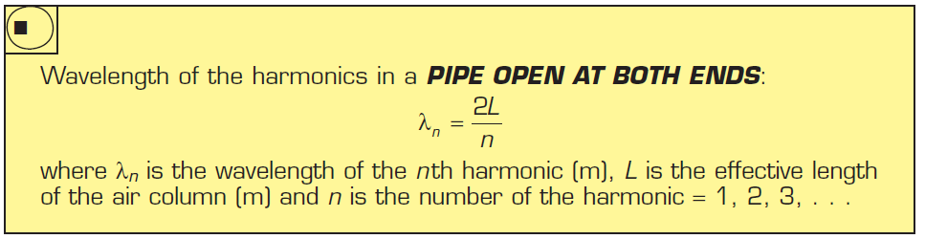

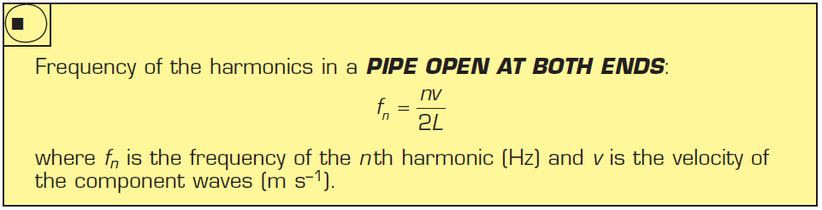

CLOSED PIPES (E.G. ORGAN PIPE)

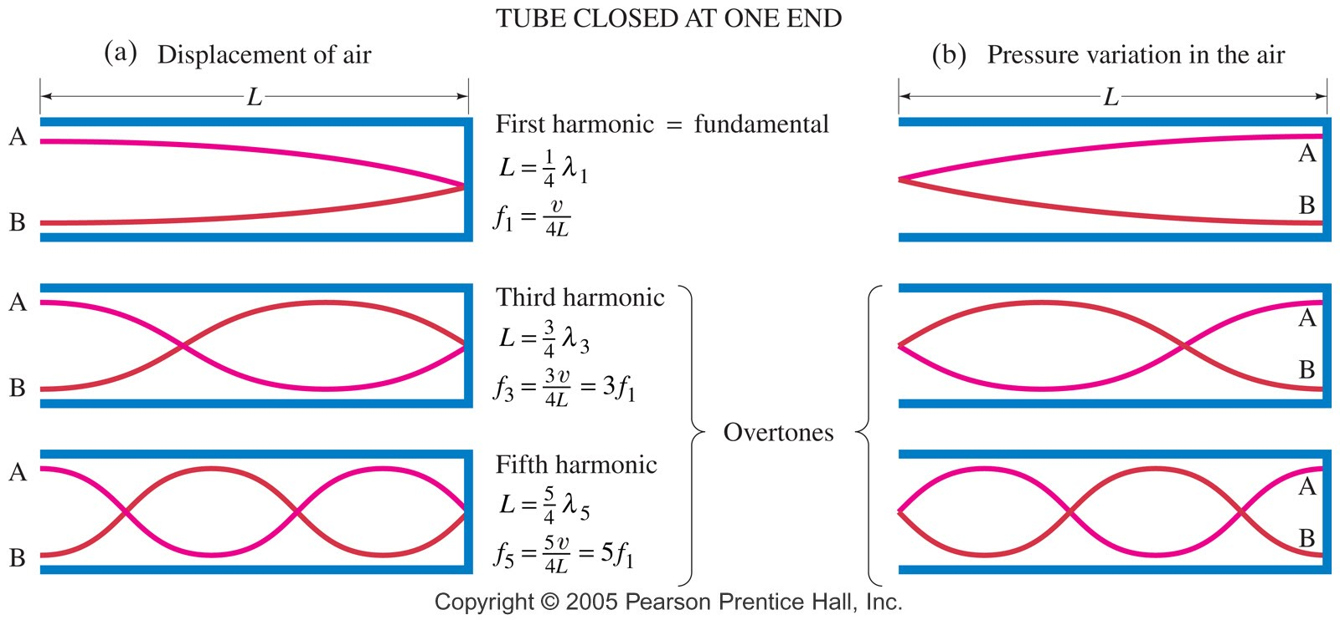

NOTE: the node at the closed end and the antinode at the open end means only odd multiples of the fundamental are possible

CLOSED PIPES: EQUATIONS

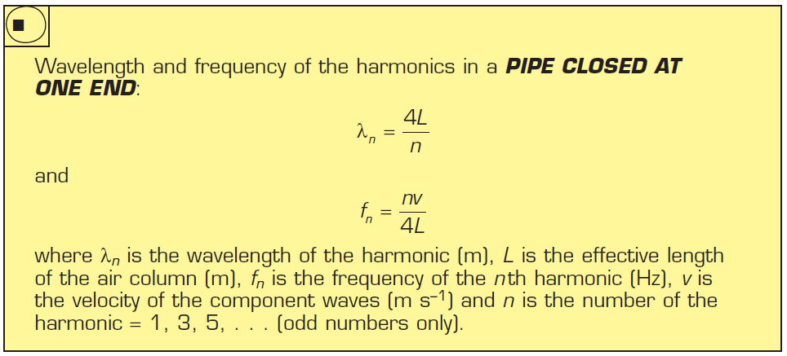

# HEATING PROCESSES – UNIT 1.1

Notes from the textbook

KINETIC PARTICLE MODEL

assumptions behind the kinetic particle model:

* all matter is made up of very small particles (atoms or molecules)
* the particles are in constant motion
* overall, no kinetic energy is lost or gained during elastic collisions between particles
* there are forces of attraction and repulsion between the particles in a material
* the distances between particles in a gas are large compared with the size of the particles

SOLIDS

* in a solid, particles must be exerting attractive forces or bonds on each other for the matter to hold together in its fixed state
* there also must be repulsive forces otherwise it would collapse
* the particles are held in a fixed position by the forces (usually in a lattice)
* the particles aren't completely still, they vibrate around average positions

LIQUIDS

* still a balance of attractive and repulsive forces
* the particles have more freedom to move around
* particles collide but remain attracted to each other.: the liquid remains within a fixed volume but with no fixed shape

GASES

* particles are in constant, random motion, colliding with each other and the walls of the container
* particles move rapidly in every direction.: filling the volume of any container
* particle speed is high enough that when the particles collide, the attractive forces aren't strong enough to keep the particles close together
* repulsive forces = particles move + spread in other directions

INTERNAL ENERGY + TEMPERATURE

* heat (measured in Joules) = transfer of thermal energy from hot → cold objects
  + is observed by a change in temperature, change of state or expansion
* when a solid is 'heated', its particles gain kinetic energy or potential energy
* heat = energy being transferred
* internal energy = total kinetic + potential energy of the particles in a substance
* heating an object changes the internal energy by affecting its kinetic / potential energy
* internal energy is associated with the rapid and chaotic motion of the particles

------

# CONDUCTION – UNIT 2.2

Notes from the textbook

* if 2 objects are at different temperatures and are in thermal contact then thermal energy will transfer from the hot object to the cold one

CONDUCTION

* heat is transferred from one place to another without net movement of particles
* all materials will conduct heat to some extent but is most significant in solids
* good conductors conduct heat readily
* poor conductors are called insulators
* conduction can happen in 2 ways:
  + energy transfer through molecular or atomic collisions
  + energy transfer by free electrons

THERMAL TRANSFER BY COLLISION

* particles in a solid are constantly vibrating within the material structure and ∴ interact with neighbouring particles
* if one part of the material is heated, the particles there will vibrate and the neighbouring particles will pass on this kinetic energy via the bonds
* can be quite slow since the mass of the particles is relatively large and vibrational velocities are fairly low
* materials for which this method of conduction is the only means of heat transfer are likely to be poor conductors of heat or even thermal insulators
  + glass, wood and paper are poor conductors of heat

THERMAL TRANSFER BY FREE ELECTRONS

* some materials, particularly metals, have electrons that aren't involved in a bond ∴ they are freely moving (delocalised)
* if a metal is heated, then the positive ions will gain extra energy alongside the free electrons
* an electron's mass is less than the positive ions, even a small energy gain will result in a very large gain in velocity
* the free electrons provide means by which heat can be quickly transferred throughout the whole material
* ∴ metals are good conductors of electricity and heat

THERMAL CONDUCTIVITY

* the ability of a material to conduct heat
* is temperature dependent and measured in Wm-1K-1

# HEATING AND COOLING

ASSUMPTIONS OF KINETIC THEORY

* All matter is made up of tiny particles (atoms or molecules).
* Particles are in constant motion.
* Collisions between the particles are perfectly elastic (no KE is lost/gained during the collision).
* There are attractive and repulsive forces between the particles in a material – insignificant in a gas.

HEAT vs INTERNAL ENERGY vs THERMAL ENERGY

Internal energy

Internal Energy is the sum total of all the kinetic and potential energy of all the particles (atoms or molecules or ions) in an object.

* Internal Energy is limited to a definite amount.

Internal energy is represented by the potential energy and kinetic energy in the bonds of any material. Why do gases not have potential energy?

* In a gas, the molecules are so far apart that there are no intermolecular interactions. So there is no potential energy. Therefore the energy is entirely kinetic

Heat

Heat is the transfer of energy from one object to another because of a difference in temperature. It flows from HOT to COLD.

SI unit: Joules, J

Heat is **NOT** the energy an object contains. Heat **IS** the energy that flows from a hot object to a cold object. Heat can flow indefinitely between two objects provided a temperature difference is maintained between them. The direction of heat flow between two objects depends on their temperature, **NOT** how much internal energy they each contain.

*Example:*

*Which has greater internal energy?*

*Which direction will the heat flow?*

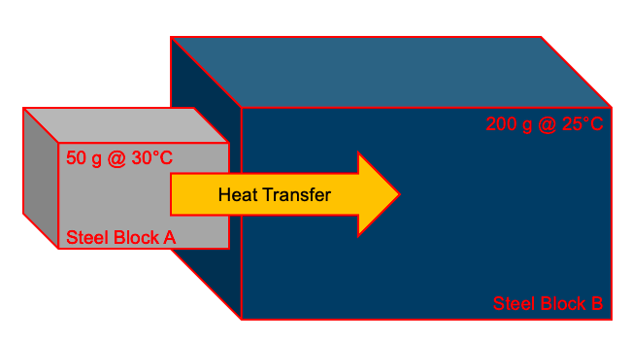

Thermal Energy

The proportion of the internal energy of a system that is responsible for the temperature of the system.

TEMPERATURE

Temperature is a measure of the degree of hotness of a substance

Temperature is a measure of the average kinetic energy of the particles in a body

**It is the average KE of the substance.**

* Heat energy normally moves from regions of higher to lower temperature.

What is the condition for thermal equilibrium?

Two objects are said to be in thermal equilibrium with each other if there is not net transfer of heat energy between them

This will only occur if both objects are at the same temperature.

TEMPERATURE VARIATION

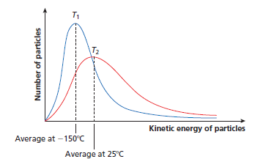

ABSOLUTE ZERO (0K)

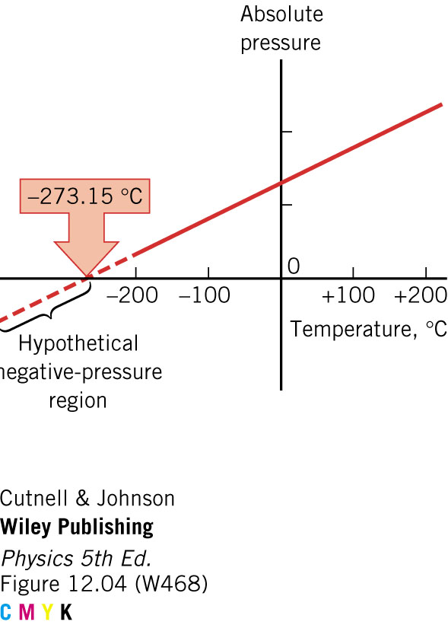

* Absolute zero is the lowest possible temperature where objects have no KE

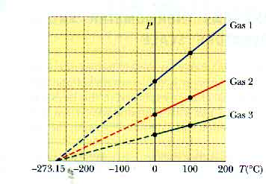

The graph above shows that the pressure of all gases will fall to zero at absolute zero which is approximately - 273oC.

THE KELVIN SCALE

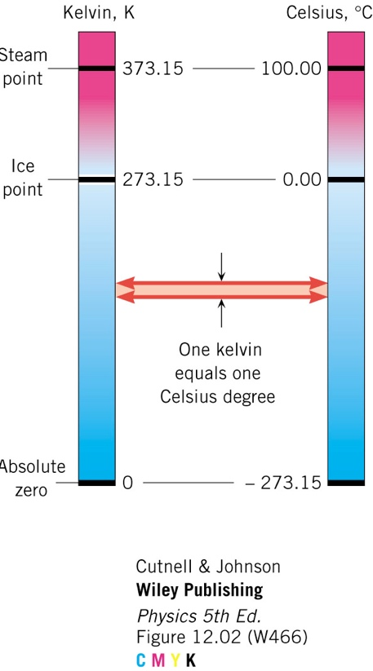

Converting between scales:

A change of one degree Celsius is the same as a change of one kelvin.

Therefore:

*oC = K - 273.15*

*K = oC + 273.15*

PARTICLES IN A SOLID, LIQUID AND GAS

Solid – particles are in constant motion about fixed positions.

Liquid – particle have greater KE and move more freely past one another. Has a fixed volume but not a fixed shape.

Gas – particles are free to move independently of each-other.

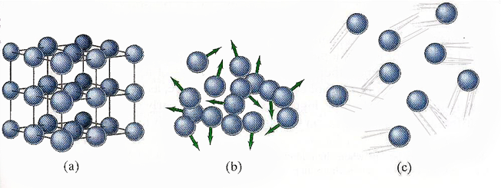

THE EFFECT OF HEATING A SUBSTANCE

As a material is heated, the particles gain KE and PE and move away from their equilibrium positions

For a substance to change state, it must receive enough energy for the particles to move away from each other.

Work is done to overcome the interparticle forces, but the speed of the particles does not change. There is an increase in PE of the particles.

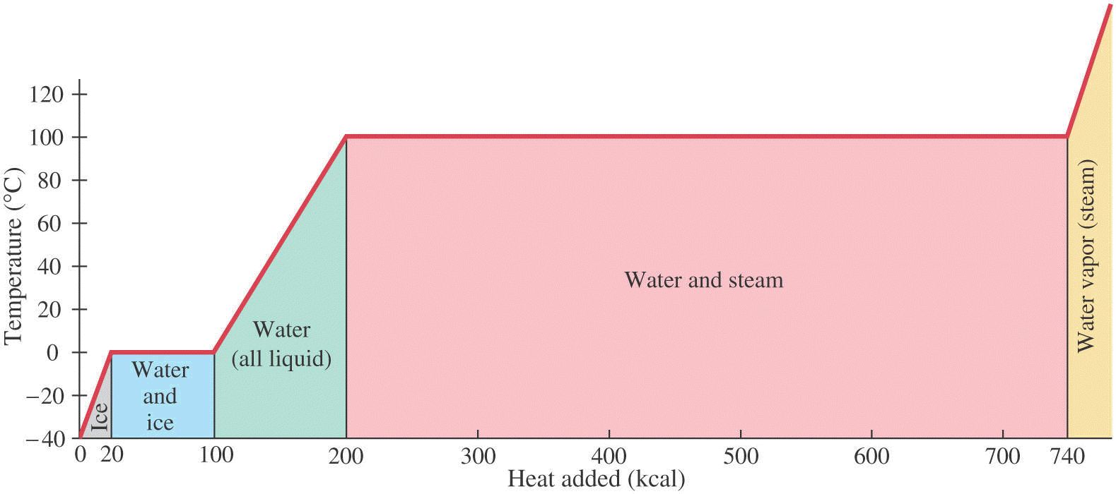

kcal = kilocalere

1 calerie is the amount of energy required to raise the temperature of 1 gram of water by one degree Celsius

THERMAL EXPANSION: THERMOSTATS

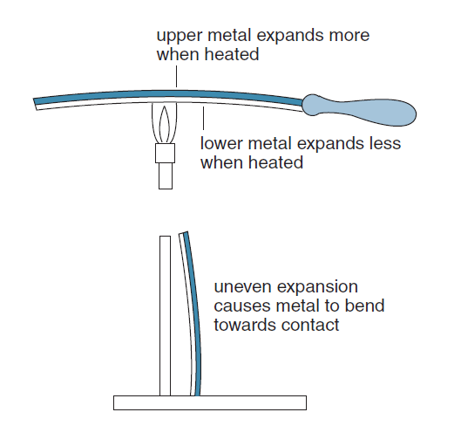

THERMAL EXPANSION OF WATER – A SPECIAL CASE

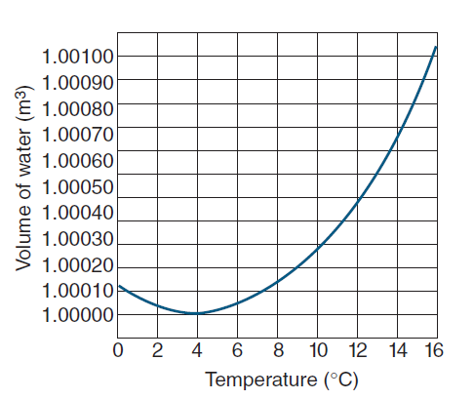

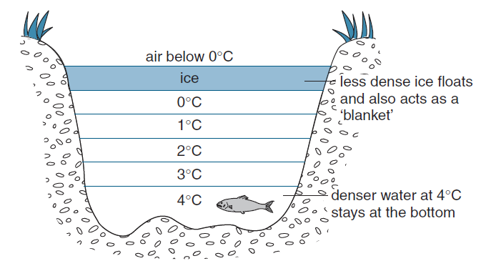

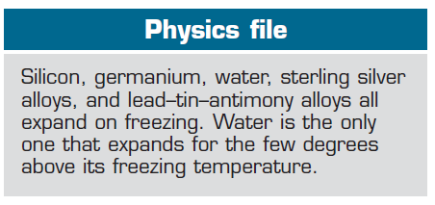

## SPECIFIC HEAT CAPACITY

Specific heat capacity of a substance is the amount of energy required to increase the temperature of one kilogram by one degree Celsius (or Kelvin), without change of phase.

Symbol: c

Unit: J kg-1 K-1

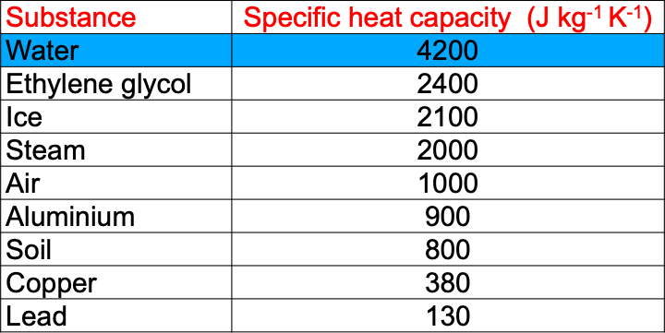

To calculate the transfer of energy required for a particular temperature change the following general equation is used:

$$ΔQ=mcΔT$$

ΔQ = heat energy transferred (J)

m = mass in kg

ΔT = change in temperature (°C or K)

c = specific heat capacity of the material/object

Example

Two cups of coffee each have 100 g of liquid in them. Cup A loses 6 kJ as its temperature drops from 60°C to 30°C while cup B loses 8 kJ as its temperature drops from 45°C to 20°C.

1. Determine the specific heat capacity of the coffee in cup A and the coffee in cup B.
2. Determine which of the coffee, the one in cup A or the one in cup B is more concentrated.

CONSERVATION OF ENERGY

* A closed system is one where no energy or matter can enter or leave it. e.g. (The universe)
* Energy within the system can be converted from one form to another and can be transferred from place to place.
* The total energy within the closed system remains constant.
* A open system is one where energy and or matter can enter or leave it. e.g. (The sea)

THERMAL EQUILIBRIUM

For thermal equilibrium, the heat gained by the colder material equals the heat energy lost by the hotter material.

* *(This does not necessarily mean that both materials will have the same internal energy. That would only occur if the two materials have the same mass and specific heat)*

METHOD OF MIXTURES

* Heat lost by hottest material = the heat gained by the cooler material
* The mixed materials will reach an equilibrium temperature
* Assumptions must be made when using this method
* The largest volume of water has the smallest temperature change
* The smallest volume of water has the largest temperature change
* 1 Litre of water has a mass of 1 kg

## LATENT HEAT

Latent heat is the energy required to change the state of 1 kg of a substance: symbol L

$$Q = Lm$$

* Lf = latent heat of fusion (melting)
* Lv = latent heat of vaporisation

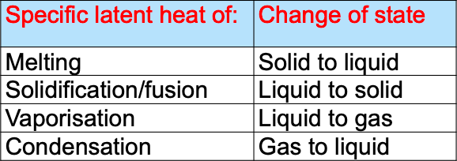

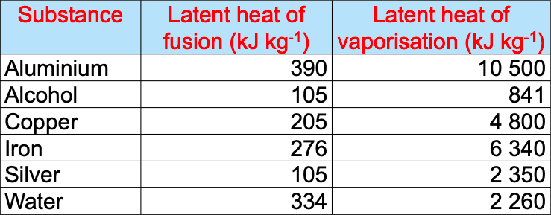

USING HEATING CURVES

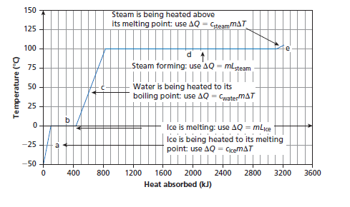

# CONDUCTION, CONVECTION, RADIATION



ENERGY TRANSFER MODELS

Heat energy always moves from a region of high temperature to a region of low temperature.

Heat energy can be transferred by conduction, convection or radiation.

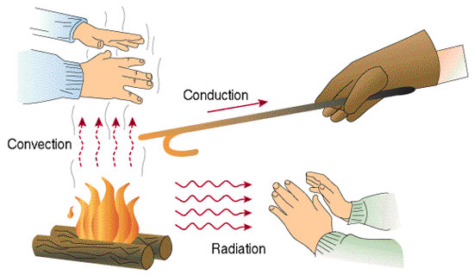

CONDUCTION

Conduction is the transfer of heat energy through a substance by particle collision with no net movement of particles.

CONDUCTORS AND INSULATORS OF HEAT

molecular collisions

As one end of a material is heated, the molecules there move faster and faster.

As they collide with their slow moving neighbours they transfer some of their KE to these molecules, whose speeds thus increase.

These in turn transfer some of their KE by collisions with molecules still further along the object.

Thus KE of thermal motion is transferred by molecular collisions along the object.

* Molecular collisions alone = Poor conductors

free electrons

e-1 have a tiny mass compared to atoms, small energy gain = very large gain in velocity.

Collisions of free electrons within the material transfer heat throughout the whole material very quickly.

* In metals, free electrons are mainly responsible for conduction 🡪 good conductors

THERMAL CONDUCTORS

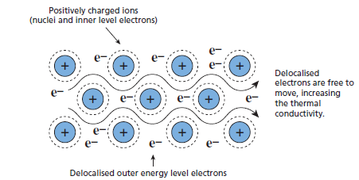

* Metals are particularly good heat at conduction. The delocalised valence electrons transfer energy to other electrons and atoms at a faster rate than atoms that are tightly bonded together.
* Thermal conductivity measures how much energy per second can flow through 1 metre of a material to raise its temperature by 1K.
* Solids are better conductors of heat than liquids or gases.

THERMAL INSULATORS

* Almost all non-metal materials, including gases, are insulators.
* Unlike metals, non-metals do not have free, delocalised electrons.
* Energy transfer occurs between relatively fixed neighbouring particles.

CONVECTION

* Convectionis the transfer of heat energy by bulk movement of particles.
* The flow of particles away from a warmer to a cooler region produces a convection current**.**
* These only occur in fluids

CONVECTION IN WATER

* If one part of a fluid is heated, the material there will expand and so become less dense.
* The hotter material, being less dense, will rise and the colder, denser material will tend to sink.
* This gives rise to a ‘convection current’.

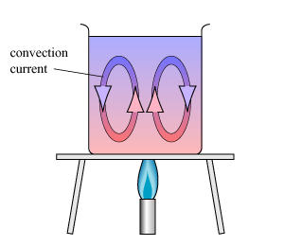

RADIATION

* Radiation is the transfer of energy without a medium.
* Unlike conduction and convection, radiation does not involve particles.
* Except at 0 K, all objects emit electromagnetic radiation

RADIATION ENERGY AND WAVELENGTH

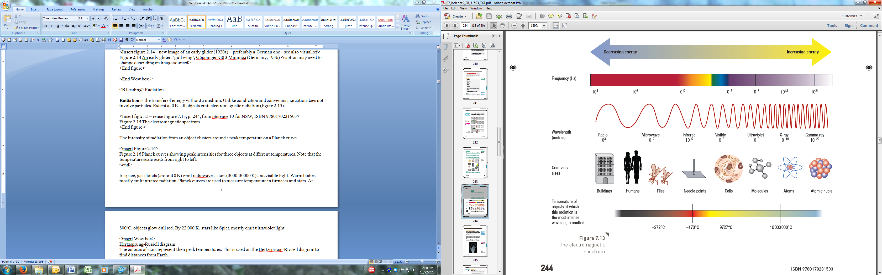

PLANCK CURVES

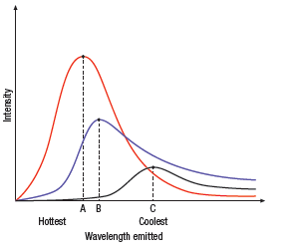

EMISSION AND ABSORPTION OF RADIATION BY SURFACES

Black or dark-coloured surfaces absorb more heat than white or light-coloured surfaces.

* Hence the inside of a black car gets hotter than a white car on a hot sunny day.

A black surface will also radiate more heat than a white surface at the same temperature.

* Hence dark clothes will radiate more energy, an on a cool night will be cooler than white clothes of the same material. White clothes are cooler during a hot sunny day when heat is mainly transferred to you from the environment.

The texture of the surface will also impact on the emission and absorption of radiant heat.

* Highly reflective surfaces enable energy to be radiated efficiently while matt surfaces do not.

DEWAR FLASK

A Dewar flask is a vacuum flask, used for hot and cold liquids.

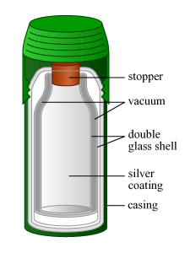

## APPLICATIONS OF CONDUCTION, CONVECTION, RADIATION

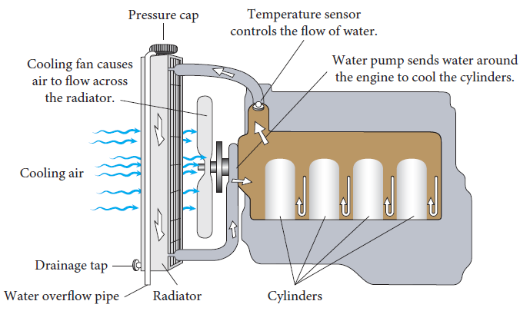

CAR COOLING SYSTEM

There are two types of cooling systems found on cars: liquid-cooled and air-cooled.

Liquid Cooling

* The cooling system on liquid-cooled cars circulates a fluid through pipes and passageways in the engine. As this liquid passes through the hot engine it absorbs heat, cooling the engine. After the fluid leaves the engine, it passes through a heat exchanger, or radiator, which transfers the heat from the fluid to the air blowing through the exchanger.

Air Cooling

* Some older cars, and very few modern cars, are air-cooled. Instead of circulating fluid through the engine, the engine block is covered in aluminum fins that conduct the heat away from the cylinder. A powerful fan forces air over these fins, which cools the engine by transferring the heat to the air.

Car coolant

What is the purpose of using coolants other than pure water in modern automotive cooling systems?

Cars operate in a wide variety of temperatures, from well below freezing to well over 38° so whatever fluid is used to cool the engine has to have a very low freezing point, a high boiling point, and it has to have the capacity to hold a lot of heat. The fluid that most cars use is a mixture of water and ethylene glycol (C2H6O2), also known as antifreeze.

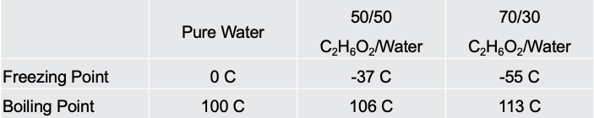

The cooling system uses **pressure** to further raise the boiling point of the coolant. Just as the boiling temperature of water is higher in a pressure cooker, the boiling temperature of coolant is higher if you pressurize the system.

Pressure Valve

* When the fluid in the cooling system heats up, it expands, causing the pressure to build up. The cap is the only place where this pressure can escape, so the setting of the spring on the cap determines the maximum pressure in the cooling system.
* When the pressure reaches 15 psi, the pressure pushes the valve open, allowing coolant to escape from the cooling system. This coolant flows through the overflow tube into the bottom of the overflow tank. This arrangement keeps air out of the system.
* When the radiator cools back down, a vacuum is created in the cooling system that pulls open another spring loaded valve, sucking water back in from the bottom of the overflow tank to replace the water that was expelled.

Thermostat

The thermostat's main job is to allow the engine to heat up quickly, and then to keep the engine at a constant temperature. It does this by regulating the amount of water that goes through the radiator. At low temperatures, the outlet to the radiator is completely blocked - all of the coolant is recirculated back through the engine.

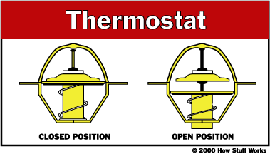

Radiator

A radiator is a type of heat exchanger. It is designed to transfer heat from the hot coolant that flows through it to the air blown through it by the fan.

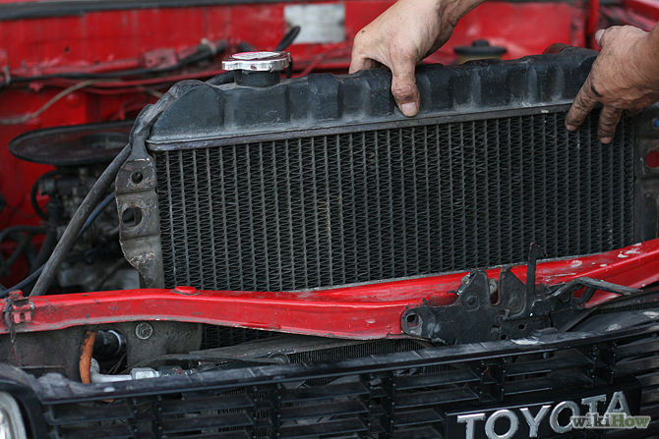

REFRIGERATORS AND AIR CONDITIONERS

Energy is pumped from the space to be cooled to the outside air or, if heating is required, energy is pumped in.

Inside a heat pump, a volatile liquid, known as a refrigerant, is used to remove heat. The refrigerant is circulated inside a closed circuit of pipes by a pump.

Evaporation occurs inside the evaporator pipes as pressure is reduced through an expansion valve.

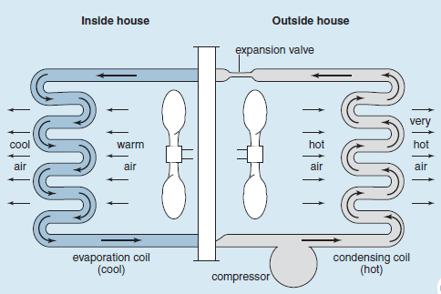

Example Question

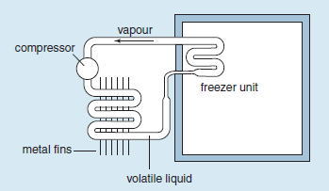

Explain what happens in the pipes of the freezer unit, stating clearly how this section of the system manages to reduce temperature.

* Refrigerant fluid in the pipes evaporates, removing energy from inside the refrigerator.

Why is this part of the unit situated toward the top of the refrigerator?

* To aid natural convection inside the refrigerator. The cooler air is denser and will fall to the bottom of the refrigerator, cooling the whole interior.

What is the purpose of the metal fins?

* Metal fins increase the surface area exposed to the outside air, increasing the transfer of heat away from the refrigerator.

CONTROLLING THERMAL ENERGY EFFICIENTLY

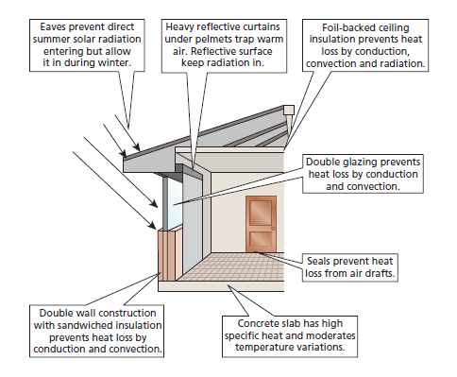

* Seals prevent heat loss from air drafts
* High specific heat concrete slab used to moderate temperature variations
* Double wall construction with sandwiched insulation prevents heat loss by conduction and convection

CONTROLLING THERMAL ENERGY IN HOUSES

* Heavy reflective curtains under pelmets trap warm air, the reflective surface keeps radiation in.
* Eves prevent direct summer solar radiation entering but allow it in during winter.
* Double glazing prevents heat loss by conduction and convection

PELMETS REDUCE HEAT LOSS

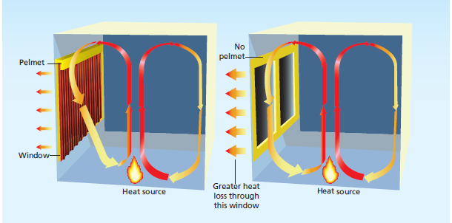

# ELECTRICITY

CHARGE INTERACTIONS

Like charges repel. Opposite charges attract.

A neutral object has the same number of positive charges as negative charges.

Neutral objects do not attract or repel other neutral objects.

MEASURING CHARGE

Symbol = q

Unit = coulomb, C

* One electron has a charge of 1.6 x 10–19 C.
* To get one coulomb of charge you need 6.2 x 1018 electrons or protons.
* Charge cannot be created or destroyed, but it can move from one object to another.

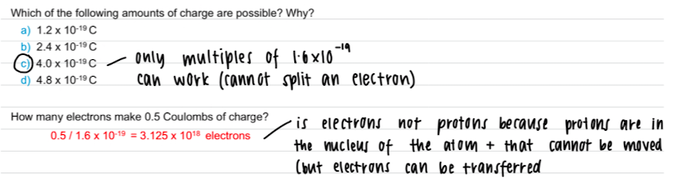

INSULATORS AND CONDUCTORS

Insulators are materials that do not allow electric charge to flow easily. Most non metal solids are insulators.

Conductors are materials that allow electric charge to flow easily. Metals are good conductors.

Semi-Conductors act as insulators until certain conditions are applied. Then they can allow electric charge to flow.

ELECTRIC CURRENT (I)

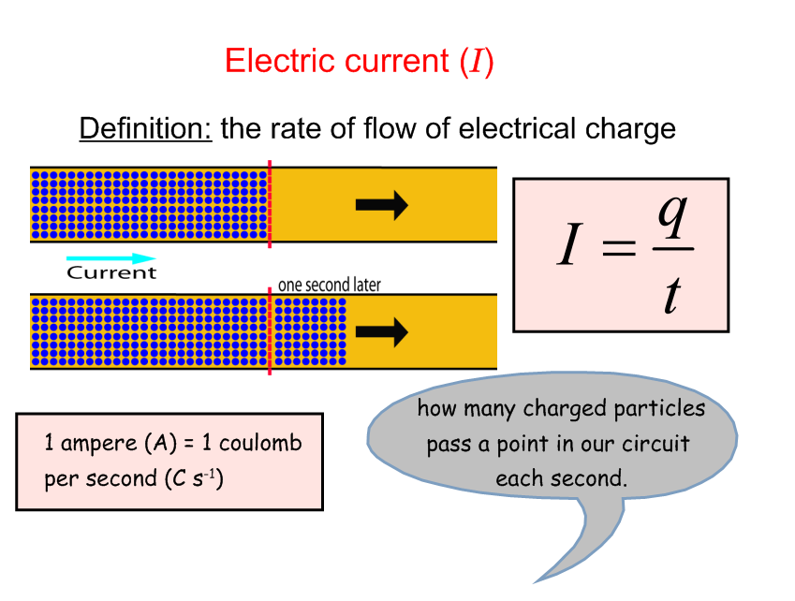

BULK MOVEMENT OF ELECTRONS

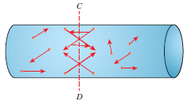

Conduction electrons move randomly.

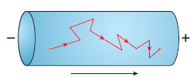

Conduction electrons drift towards the positive terminal in bulk

ELECTRIC CURRENT

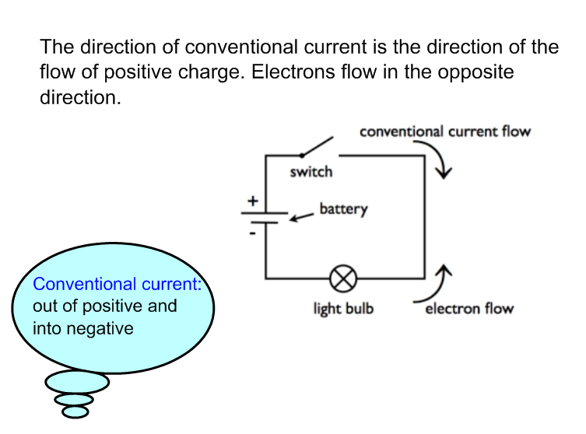

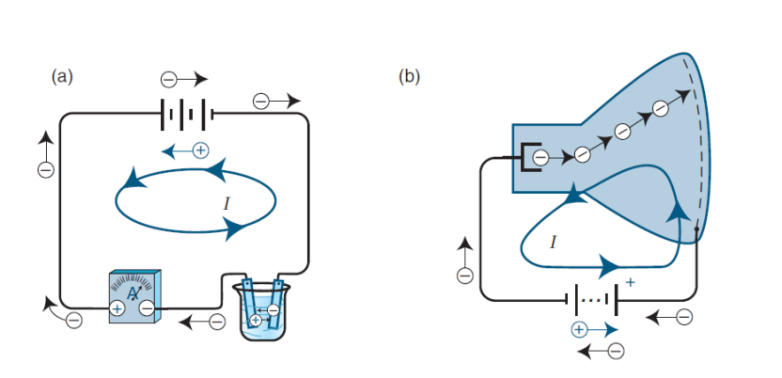

DIRECT CURRENT AND ALTERNATING CURRENT

Direct Current (DC) Current flows one way

Alternating current (AC) The current direction alternates – changes direction approximately 50 times every second.

ELECTRICAL POTENTIAL

Electrical potential drives the current in a circuit. Because of this it is sometimes referred to as the electromotive force (EMF, $ε$).

*EMF (Electromotive force)*

Symbol: $ε$

Definition: the energy per unit charge

Units: Volts (1 V = 1 J.C-1)

ELECTRICAL POTENTIAL

Work (W) is done whenever you lose or gain energy.

A charge, q, moving through a potential difference, ΔV, will lose energy given by ΔE=q ΔV or simply E=qV (also written as W = qV).

MEASURING CURRENT AND VOLTAGE

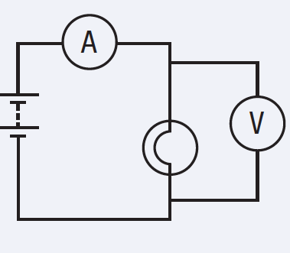

The *ammeter* measures the amount of charge that passes a point in a given time

It is placed in series with the part of the circuit where the current is being measured

The voltmeter is measuring the difference in potential between two points. It is placed in parallel across an element

POWER

Power (*P*) is defined as the rate of energy transfer, either delivery or dissipation. It is the energy transfer per unit of time.

Units: Watts (W).



ANOTHER UNIT FOR ELECTRICAL ENERGY:

*The total amount of energy used by an appliance depends on how long the appliance is switched on for.*

*The total energy is the product of the power and time.*

*E=P.t (1 J = 1 watt x 1 second)*

*As time is most likely to be measure in hours (not seconds) we use the unit of energy 'watt hour' or 'kilowatt hour' where:*

*E* (kWh) = *P* (kW) x *t* (h)

= 103 W x (60 min x60 s)

Thus

1 kilowatt-hour = 1 kWh = 3.6 x 106 J

KIRCHOFF’S LAWS

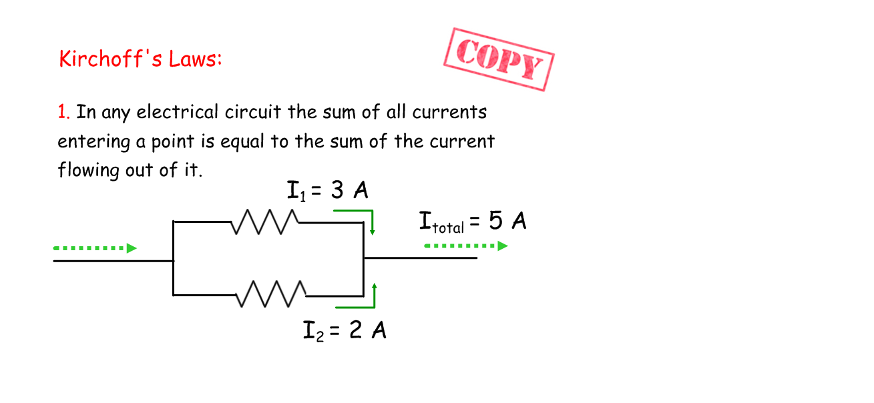

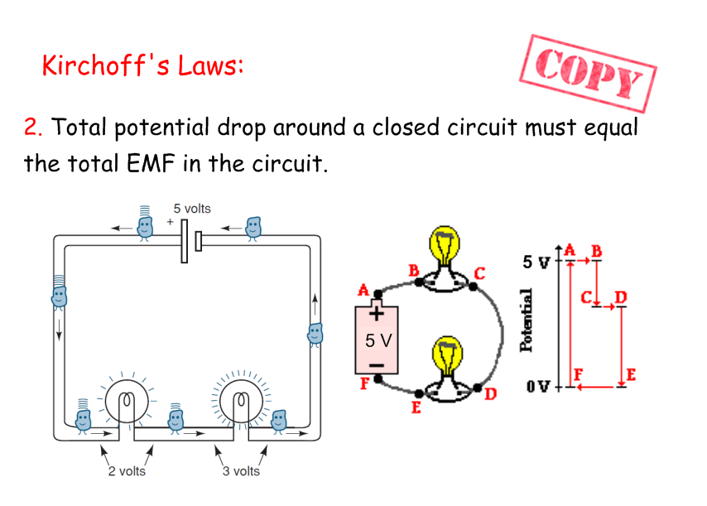

## RESISTANCE

RESISTIVITY

Resistivityrefers to how much a material opposes the flow of charges.

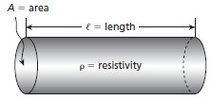



Where R = resistance

ρ= resistivity

l = length

A = cross sectional area.

OHM’S LAW

Resistance affects current and voltage.

Definition:

The resistance (R) of a resistor is defined as the ratio of the potential difference (V) to the current (I)

Units: ohms (Ω)



$1 Ω=1 V.A^{-1}$

OHMIC RESISTOR

The resistance of ohmic device is constant for a wide range of voltages and currents.

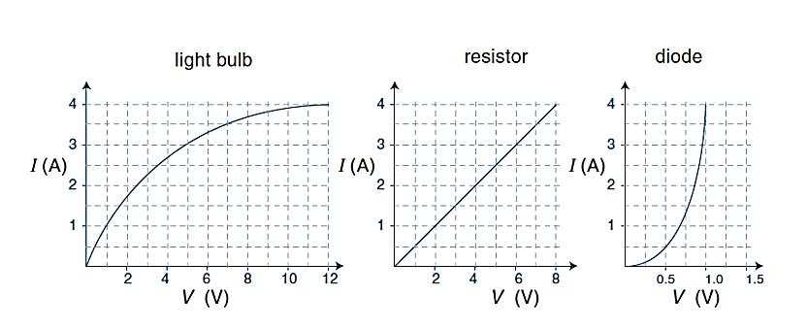

NON-OHMIC RESISTOR

In a non ohmic device the resistance changes as you vary voltage and current.



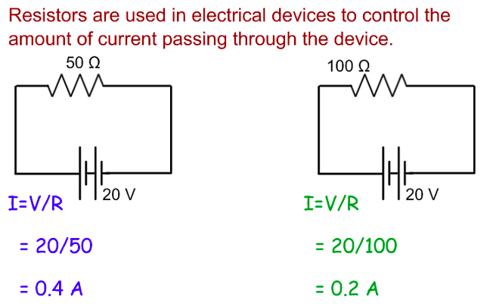

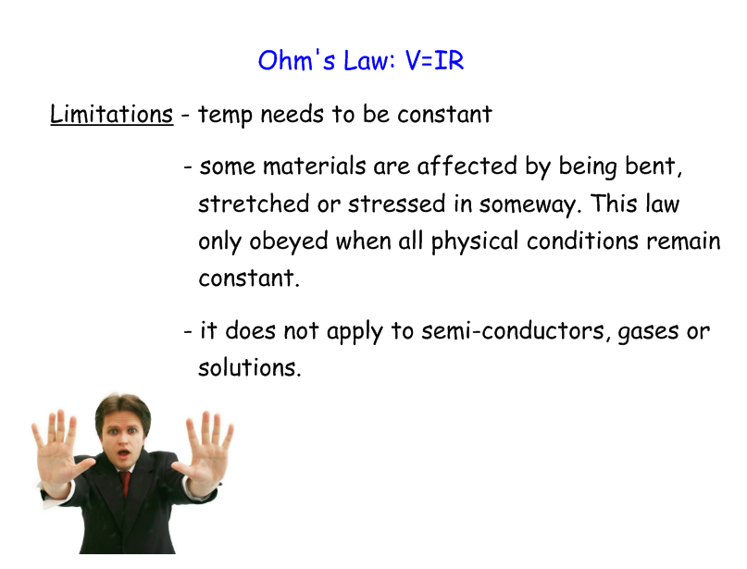

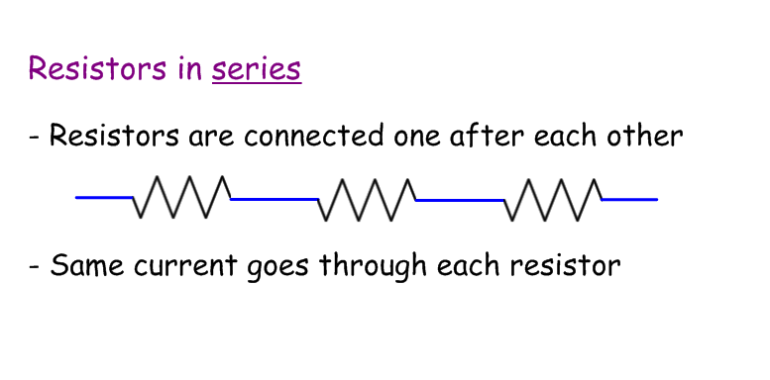

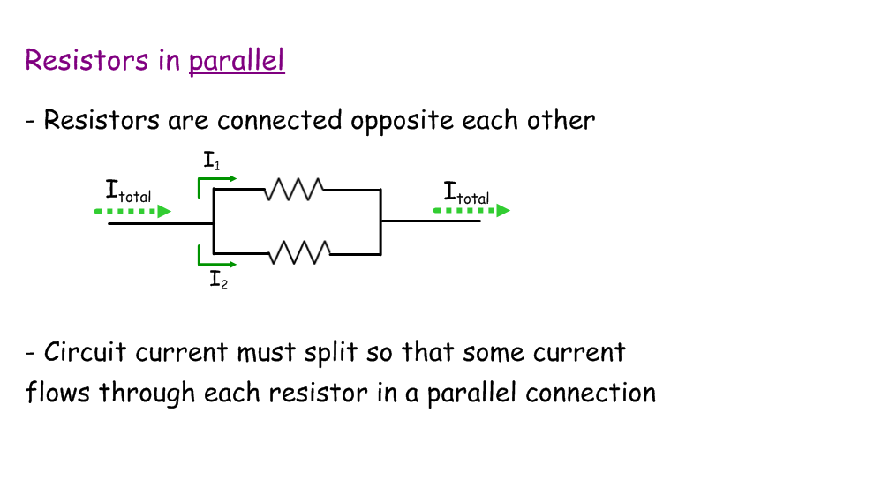

RESISTORS IN SERIES CIRCUITS

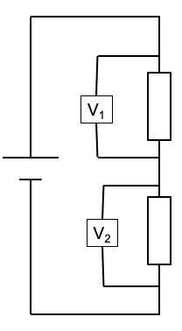

I = constant

Rt = R1 + R2 + …

*V*t = *V*1 + *V*2

 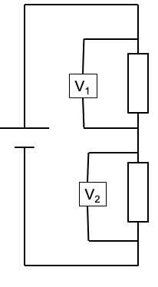

The current is the same in each resistor



The potential difference is divided in the ratio of the resistances.

RESISTORS IN PARALLEL CIRCUITS

If the source of energy per charge is across both resistors in parallel is the same, both resistors use up the same amount of energy per charge.

The energy per charge provided by a battery is all used in the circuit.

The potential difference is the same across both resistors.

The current is shared between the resistors.

RESISTORS IN PARALLEL CIRCUITS   
 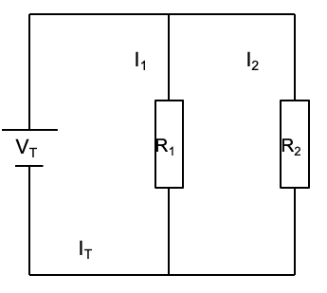

*V*t = *V*1 = *V*2

*I*t = *I*1 + *I*2



The potential difference across each resistor is the same, so:

*V* = *I*1 *R*1 = *I*2 *R*2

The ratio of the current in each resistor is equal to the inverse ratio of the resistances.



THÉVENIN’S THEOREM  
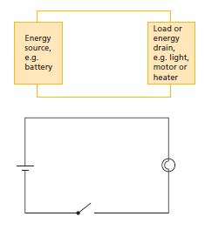

Thévenin’s theorem allows us to reduce complex circuits into a simpler form.

All circuits, even if they have several energy sources and several energy loads, can always be reduced to the simplest of forms

A circuit can be reduced to one source that is the equivalent of all the sources.

A circuit can be reduced to one load that is the equivalent of all the loads.

COMBINATION CIRCUITS  
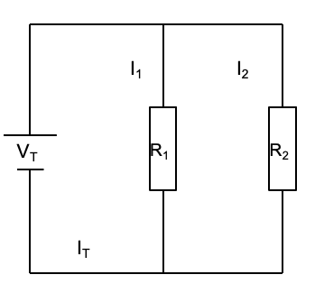

To use V=IR on the whole circuit you need to know the total resistance.

To use V=IR on one component you need to know the voltage drop and/or the current in that component.

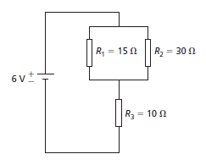

R1 is in parallel with R2 and both of these are in series with R3

For circuits with ohmic resistors:

Use Vt = ItRt on whole circuit

Use Vn = InRn on individual components